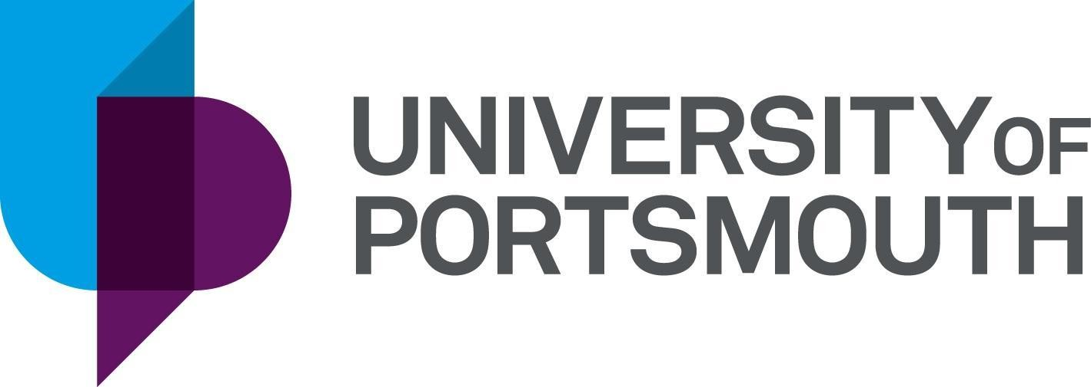

The University of Portsmouth Women’s Football Club

Assistant Coach

Purpose of the Role

The University of Portsmouth Women’s Football Club consists of two competitive teams that play in weekly BUCS (British Universities and Colleges Sport) leagues, with the 1st team in Tier 1 of the South Eastern league, and the 2nd team in Tier 2 of the South Eastern league. The club also has a development team which will be competing in the Hampshire local league.

The club require an assistant coach to work alongside the 1st and 2nd team for the 2025/26 season at training, and step in to cover fixtures when required. The successful candidate will be available to support the delivery of regular training sessions from September - April, and attend fixtures when scheduled throughout the season.

The team trains on Monday evenings from 8pm-10pm at Langstone Sports Campus. Fixtures are scheduled for Wednesday afternoons (times & locations vary).

Main Responsibilities:

* Collaborate with coaching staff to plan, deliver and evaluate training sessions
* Communicate with the club captain and team captains on squad selection and match day details where required
* Attend 1st and/or 2nd team ‘home’ and ‘away’ games when required
* Support the club committee and coaching staff with the organisation and delivery of the Taster Day and team trials
* Promote the club’s philosophy
* Adhere to the University of Portsmouth’s Code of Conduct

Criteria:

* Essential: EE Playmakers qualification (please note this is a free online course accredited by the FA for new / aspiring coaches) or FA Introduction to Coaching football qualification
* Desirable: Previous coaching experience
* Desirable: An understanding of Women’s Football within higher education

**Please note this is a voluntary role, however, coaching kit and funding towards coaching qualifications can be provided.**

Application Process:

To apply for this role, please complete the following Google Form: <https://docs.google.com/forms/d/1d3gsxkfWAfYGcmAjqWK_BbsuSKFu3tKnuR4NE7CH3iw/edit> The deadline for applications is the 22nd August 2025.